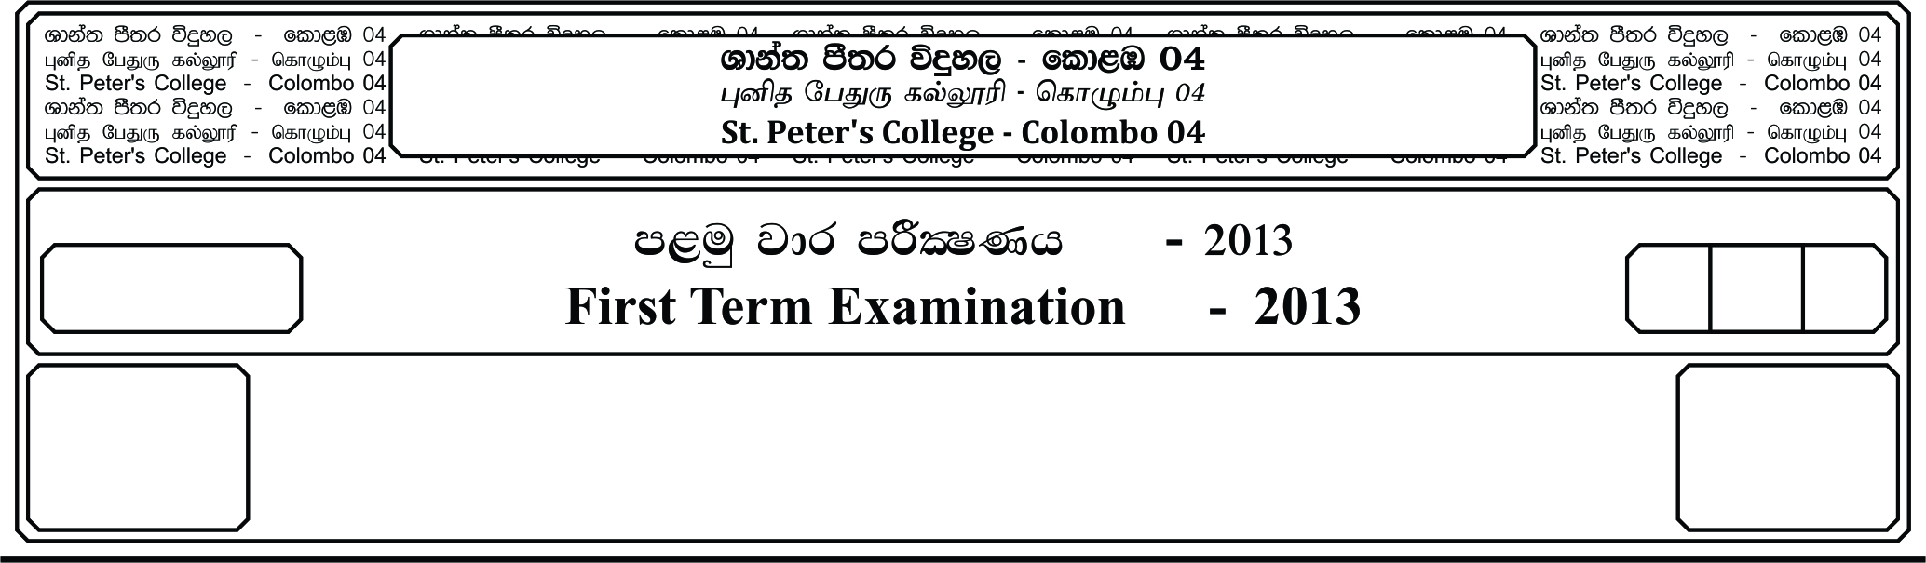

13 fY%aKsh

GRADE 13

E

meh 03

03 Hours

I

**fojk jdr mÍCIKh - 2019**

**Second Term Examination - 2019**

cSj úoHdj - »»

**BIOLOGY – II**

09

19.11.2019

❖ **Instructions**

**-** This question paper consists of 08 questions in 12 pages.

**-** This question paper comprises of part A and part B

**-** The time allocated for both parts is three hours.

**PART A - ( Structured Essay (Page 2-11)**

**-** Answer all four questions on this paper itself.

- Write your answers in the space provided for each question. Note that the space

provided is sufficient for your answers and extensive answers are not expected.

**PART B - (Essay (Page 12 )**

- Answer all four questions.

- Use the papers supplied for this purpose. At the end of the time allocated for this

paper, tie the two parts together so that part A is on the top of part B before

handling over the supervisor.

- You are permitted to remove only part B of the question paper from the

examination hall.

**For Examiners Use Only**

|  |  |  |
| --- | --- | --- |
| **Part** | **Question No** | **Marks** |
| **A** | 1 |  |
| 2 |  |
| 3 |  |
| 4 |  |
| **B** | 5 |  |
| 6 |  |
| 7 |  |
| 8 |  |
| 9 |  |
| **Total** |  |  |
| **Percentage** | |  |

**Final Marks**

|  |  |
| --- | --- |
| **Paper I** |  |
| **Paper II** |  |
| **Total** |  |

**Part A – Structured Essay**

★ Answer all 04 questions on this paper itself.

**01.A.** i. What is meant by cell organelle?

…………………………………………………………………………………………

…………………………………………………………………………………………

…………………………………………………………………………………………

ii. State the cell organelle which perform following functions.

a. Stores ions - ………………………….

b. Manufacturing cellulose - ………………………….

c. Transport residue material out of the cell - ………………………….

d. Transport substances over the surface of the tissue - ………………………….

e. Limits and control cell growth - ………………………….

iii. State one major behaviour of chromosomes during each phase of mitosis of eukaryotic

cells.

a. Prophase - ……………………………………………………………………

b. Metaphase - ……………………………………………………………………

c. Anaphase - ……………………………………………………………………

iv. State the number of DNA molecules in genetic materials of a human body cells given

in below.

a. In somatic cell - ………………………………………….

b. Metaphase of mitosis - ………………………………………….

c. Daughter cells produced by mitosis - ………………………………………….

d. Metaphase I of meiosis - ………………………………………….

e. Metaphase II of meiosis - ………………………………………….

f. Sperm cell - ………………………………………….

v. State two biological significance of meiosis.

…………………………………………………………………………………………

…………………………………………………………………………………………

01.**B.** i. State 3 factors which favored the synthesis of organic molecules essential for the origin

of life on earth.

…………………………………………………………………………………………

…………………………………………………………………………………………

…………………………………………………………………………………………

ii. State 3 major events based on evolution of plants took place in Palaeozoic era.

…………………………………………………………………………………………

…………………………………………………………………………………………

…………………………………………………………………………………………

iii. What are the living characteristics shown by proto cell?

…………………………………………………………………………………………

…………………………………………………………………………………………

…………………………………………………………………………………………

iv. State two principles of theory of Lamarck.

…………………………………………………………………………………………

…………………………………………………………………………………………

v. State two hypothesis of theory of natural selection.

…………………………………………………………………………………………

…………………………………………………………………………………………

**01.C.** i. What is meant by artificial classification of an organisms?

…………………………………………………………………………………………

…………………………………………………………………………………………

…………………………………………………………………………………………

ii. State main 4 basis of present system of classification?

…………………………………………………………………………………………

…………………………………………………………………………………………

…………………………………………………………………………………………

…………………………………………………………………………………………

iii. What is the biological definition of a species?

…………………………………………………………………………………………

…………………………………………………………………………………………

…………………………………………………………………………………………

iv. Below shows a few genera and some features of them. Write the English letter of

matching genus infront of each feature.

a. *Nostoc* b. *Cycas*

c. *Nereis* d. *Euglena*

e. *Fasciola* f. *Nephrolepis*

g. *Gelidium* h. *Agaricus*

i. *Marchantia* j. *Ichthyopis*

k. *Chytridium* l. *Paramecium*

1. Possess photosynthetic gametophyte & sporophyte - ………………………...

2. Possess chloroplast and pellicle - ………………………...

3. Contain agar in cell wall - ………………………...

4. Possess suckers - ………………………...

5. Produce zoopores - ………………………...

6. Oral groove is present - ………………………...

7. Contain simple eyes - ………………………...

8. Possess dominant gametophyte - ………………………...

9. Possess dikaryotic filaments in mycelium - ………………………...

10. Have ability to fixing atmospheric nitrogen - ………………………...

11. Body covered with thin & moist skin - ………………………...

12. Have plam like leaves and large cones - ………………………...

**02.A.** i. a. What is secondary growth of plants?

…………………………………………………………………………………………

…………………………………………………………………………………………

…………………………………………………………………………………………

b. State the tissues involve for secondary growth and mention the types of secondary

tissues arise from each.

…………………………………………………………………………………………

…………………………………………………………………………………………

ii. State the main difference between hard wood and soft wood.

…………………………………………………………………………………………

…………………………………………………………………………………………

iii. What are stomata?

…………………………………………………………………………………………

…………………………………………………………………………………………

…………………………………………………………………………………………

iv. State 3 factors which affect for the function of stomata except Absicic acid.

…………………………………………………………………………………………

…………………………………………………………………………………………

…………………………………………………………………………………………

**02.B.** The diagram below show a life cycle of a ***Cycas***.

i

Zygote

Female Sporophyte

Male Sporophyte

a

b

c

Microsporangium

Mega sporangium

x

x

e

d

Male gametophyte

Female gametophyte

y

f

y

g

h

z

y

j

i. Name the stage/structures given as a-j

a - ……………………………….. b - ………………………………..

c - ……………………………….. d - ………………………………..

e - ……………………………….. f - ………………………………..

g - ……………………………….. h - ………………………………..

i - ……………………………….. j - ………………………………..

ii. Name x,y & z processes given in it.

x - ………………………………..

y - ………………………………..

z - ………………………………..

iii. a. Draw a labeled diagram of male gametophyte of Anthophyta.

b. State main features of above which show better adaptation for terrestrial life than

male gametophyte of *Cycas*.

…………………………………………………………………………………

iv. State main 2 differences of female gametophyte of *Cycas* and Anthophytes.

…………………………………………………………………………………

…………………………………………………………………………………

…………………………………………………………………………………

v. State 3 unique features of Anthophytes.

…………………………………………………………………………………

…………………………………………………………………………………

…………………………………………………………………………………

**02.C.** i. a. What are plant growth regulators?

…………………………………………………………………………………

…………………………………………………………………………………

…………………………………………………………………………………

b. State main feature of plant growth regulators which differ from animal hormones.

…………………………………………………………………………………

ii. State the type of plant growth regulator which involve to maintain following functions.

a. Prevent leaf abscission - ………………………………………………

b. Promote growth of root hair - ………………………………………………

c. Induce growth of lateral buds - ………………………………………………

d. Promote seed development - ………………………………………………

e. Promote leaf senescence - ………………………………………………

iii. What is meant by stress regarding plants?

…………………………………………………………………………………

…………………………………………………………………………………

iv. Briefly explain how plants respond to salt stress.

…………………………………………………………………………………

…………………………………………………………………………………

…………………………………………………………………………………

…………………………………………………………………………………

**03.A.** i. What is meant by vitamins?

…………………………………………………………………………………

…………………………………………………………………………………

…………………………………………………………………………………

ii. State the main function of following vitamins.

a. Retinol - ……………………………………………………………….

b. Phyloquinone - ……………………………………………………………….

c. Ascobic acid - ……………………………………………………………….

d. Calciferol - ……………………………………………………………….

iii. State main deficiency symptoms of following vitamins.

a. Folic acid - ……………………………………………………………….

b. Thiamine - ……………………………………………………………….

c. Niacin - ……………………………………………………………….

d. Riboflavin - ……………………………………………………………….

iv. a. What is Basal Metabolic Rate?

…………………………………………………………………………………

…………………………………………………………………………………

…………………………………………………………………………………

v. b. State the average values of BMR of adult Male and Female.

…………………………………………………………………………………

…………………………………………………………………………………

**03.B.** i. State main components of circulatory system.

…………………………………………………………………………………………

ii. a. What is meant by double circulation?

…………………………………………………………………………………

…………………………………………………………………………………

b. State the main advantage of double circulation over single circulation?

…………………………………………………………………………………

…………………………………………………………………………………

c. State two animal classes which possess complete double circulation.

…………………………………………………………………………………

…………………………………………………………………………………

Following diagram show a longitudinal section of a human heart. Question namber (iii)

& (iv) are based on it.

g

f

e

d

c

b

a

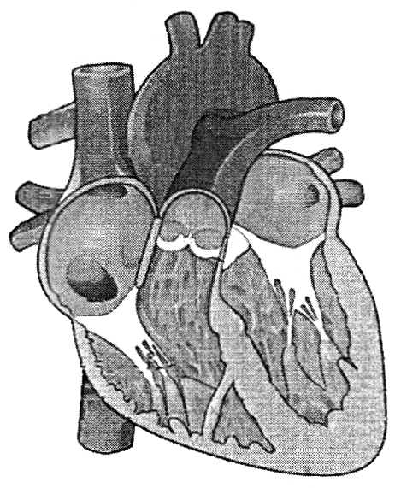

iii. Name the structure denoted in a - h

a. ……………………………….. b ………………………………..

c. ……………………………….. d ………………………………..

e. ……………………………….. f ………………………………..

g. ……………………………….. h ………………………………..

iv. State the main function of following parts.

b …………………………………………………………………………………...

c. …………………………………………………………………………………...

e. …………………………………………………………………………………...

g. …………………………………………………………………………………...

**03.C.** i. State main respiratory structure of following animals.

a. *Nereis* - ………………………………..

b *Hydra* - ………………………………..

c. Scopian - ………………………………..

d Cockroach - ………………………………..

ii. State main 4 charachteristics of respiratory surfaces.

…………………………………………………………………………………………..

…………………………………………………………………………………………..

…………………………………………………………………………………………..

…………………………………………………………………………………………..

iii. Briefly explain the affect of hydrogen cyanide on human respiratory system.

…………………………………………………………………………………………..

…………………………………………………………………………………………..

…………………………………………………………………………………………..

…………………………………………………………………………………………..

…………………………………………………………………………………………..

iv. Define following terms regarding respiratory volumes and capacities. Mention the

average values as well.

a. Residual volume - ………………………………………………………..……

……………………………………………………………………………………..

b Tidal volume - …………………………………………………..…………

……………………………………………………………………………………..

c. Total lung capacity - ……………………………………………………..………

……………………………………………………………………………………..

**04.A.** i. What is meant by Immunity?

…………………………………………………………………………………………..

…………………………………………………………………………………………..

…………………………………………………………………………………………..

ii. Briefly explain the affect of following structure/cell/compounds on Innate immunity.

a. Human skin - ……………………………………………………………..

……………………………………………………………………………………..

……………………………………………………………………………………..

……………………………………………………………………………………..

b Natural killer cell - ……………………………………………………………..

……………………………………………………………………………………..

……………………………………………………………………………………..

c. Interferons - ……………………………………………………………..

……………………………………………………………………………………..

……………………………………………………………………………………..

……………………………………………………………………………………..

iii. State 3 main characteristics of Acquired Immunity.

…………………………………………………………………………………………..

…………………………………………………………………………………………..

…………………………………………………………………………………………..

iv. State 2 Autoimmune diseases and mention the main reasons to each.

…………………………………………………………………………………………..

…………………………………………………………………………………………..

…………………………………………………………………………………………..

…………………………………………………………………………………………..

01.**B.** i. State the importance of excretion.

…………………………………………………………………………………………..

…………………………………………………………………………………………..

…………………………………………………………………………………………..

…………………………………………………………………………………………..

ii. What are the two factors which involve to determine the type of nitrogenous excretory

product in animal?

…………………………………………………………………………………………..

…………………………………………………………………………………………..

iii. a. Name the major nitrogenous excretory product in bird.

…………………………………………………………………………………...

b. State the disadvantage of producing above mention product in birds in respect

to the metabolism.

…………………………………………………………………………………...

iv. a. Name the parts of a nephron is a sequential order.

…………………………………………………………………………………...

…………………………………………………………………………………...

…………………………………………………………………………………...

b. State main 2 capillaries associated with the nephrons.

…………………………………………………………………………………...

…………………………………………………………………………………...

**01.C.** i. Name two major features which cause the nervous coordination to be faster than the

chemical coordination.

…………………………………………………………………………………………..

…………………………………………………………………………………………..

ii. State the part of the human brain which perform following function.

a. Helps in learning & remembering motor skills - ………………………………

b. Regulates thirst and water balance - ………………………………

c. Coordinates auditory and visual reflexes - ………………………………

d. Initiation of voluntary muscle contraction - ………………………………

e. Control heart and blood vessel activities - ………………………………

iii. State two structural differences of sympathetic and parasympathetic nervous system.

…………………………………………………………………………………………..

…………………………………………………………………………………………..

…………………………………………………………………………………………..

…………………………………………………………………………………………..

iv. a. What are neurotransitters?

…………………………………………………………………………………...

…………………………………………………………………………………...

…………………………………………………………………………………...

…………………………………………………………………………………...

b. Name 2 common neurotransmitters in human.

…………………………………………………………………………………...

…………………………………………………………………………………...

**Part B – Essay**

★ Answer all four questions.

05. a. Explain the electron microscopic structure of the plasma membrane.

b. Explain the resting membrane potential of a neuron.

06. Explain the role of T and B lymphocytes in adaptive immunity of human.

07. a. Explain the gross structure of human kidney.

b. Explain the role of hormones on activity of human kidney.

08. Write short notes on following.

a. Mode of nutritions in plants.

b. Blood clotting.

c. Main steps in urine formation of human.